Course Title: Non-Patient Care Elective Advanced Pharmacy Practice Experience

Course Purpose:
The goal of the Non-Patient Care Elective Advanced Pharmacy Practice Experience is to provide opportunities for students to build on knowledge and skills acquired through didactic education and introductory pharmacy practice experiences and apply them in non-patient area. This course may take place in a variety of environments where the experience may focus on pharmacy operations, medication uses systems, quality or business and management concepts.

Preceptor(s) and Site Information:
PRECEPTOR: insert the following information
Site Name:
Site Address:
Preceptor Name(s):
Preceptor Phone:
Preceptor Email:
Pharmacy Phone Number:
Pharmacy Fax Number:

Pre-Rotation Requirements for Student
Students are responsible for completing requirements set forth by the University of Florida, College of Pharmacy. Check the PharmAcademic website for site-specific forms and requirements (i.e., Drug Screen Requirements, Immunization forms. Students must request attestations at least 60 days BEFORE the scheduled rotation is to begin.
PRECEPTOR: Include any information or documentation that the student must provide (i.e. immunization requirements, HIPAA training, etc.) prior to starting rotation. Note that prerequisite knowledge and skills (recommended review of therapeutic guidelines, etc.) are specified in a subsequent section.
Learning Objectives:
At the conclusion of the Non-Patient Care Elective Advanced Pharmacy Practice Experience, students should be able to: PRECEPTOR: Include additional learning objectives as applicable to rotation experience. Please consider using the following verbs-

Lower Level of Learning High Level of Learning
Knowledge | Comprehension | Application | Analysis | Synthesis | Evaluation
cite | associate | apply | analyze | arrange | appraise
count | categorize | calculate | appraise | assemble | assess
define | classify | complete | compare | collect | choose
identify | describe | demonstrate | contrast | construct | critique
indicate | differentiate | illustrate | criticize | create | determine
list | discuss | operate | debate | design | estimate
name | distinguish | order | detect | detect | evaluate
recite | explain | practice | diagram | formulate | judge
recognize | express | predict | differentiate | integrate | measure
relate | interpret | use | distinguish | manage | rank
repeat | locate | utilize | question | organize | rate
select | report |  | separate | plan | revise
state | review |  |  | prepare | select
 |  |  |  | specify | test

- Collaborate as an interprofessional team member in a variety of healthcare settings when possible.
- Work with individuals of other professions to maintain a climate of mutual respect and shared values.
- Use the knowledge of one's own role and those of other professions to appropriately assess and address the healthcare needs of the patients and populations served.
- Demonstrate the ability to assimilate and apply basic, clinical, and social science knowledge in the care of patients and resolution of practice problems.
- Demonstrate ethical behaviors that are essential to the practice of pharmacy.
- Adhere to legal requirements in pharmacy practice
- Apply critical thinking, problem-solving, and scientific reasoning skills to the practice of pharmacy both when solving patient problems and general practice problems.
- Gather, analyze, and apply relevant scientific data, evidence-based data, and other information when solving practice problems (both patient-specific and general practice problems).
Course Outline, Schedule/Activities, and Assignment Deadlines:
Student Schedule:
PRECEPTOR:
- Provide typical schedule, daily, weekly, or monthly, as appropriate, of topics, assignments and required activities. State events or meetings inside or outside those hours the student should attend. Please schedule time to meet with the student to discuss the student’s performance at mid-point at end of the 2nd week and final evaluation at end of the 4th week.
- State the hours the student is expected to be on site and break/lunch information. If applicable, indicate the hours may not be firm, and describe situations in which a student may need to stay after hours in order to complete tasks.

PLEASE FILL IN THE FOLLOWING SCHEDULE: OTHER EXAMPLES ARE IN THE APPENDIX

Sample Rotation Schedule
Week | Monday | Tuesday | Wednesday | Thursday | Friday
1 | Orientation
2 |  |  |  |  | Midpoint Evaluation
3
4 |  |  |  |  | Final Evaluation

Interprofessional Experience Opportunities:
PRECEPTOR:
Include a statement describing any interprofessional opportunities where the student participates in meaningful interprofessional engagement on a healthcare team in both patient care and non-patient care settings. Please include a description of:
- Non-pharmacy team member(s) i.e. Physician, Nurse, PT, OT, HRNP, RT. (*Please do not include Pharmacist or Technician roles).
- What the students are doing during their interactions with non-pharmacy team members.
- How often the students are interacting with non-pharmacy team members.

Interprofessional Experience Opportunities allow students to:
  - Engage in collaborative patient care decision making with members of an interprofessional healthcare team with an emphasis on face-to-face interactions but also incorporating other communication options. OR
  - Work face-to-face as a member of a collaborative, interprofessional team, i.e. rounding, quality improvement team. OR
  - Identify, evaluate, communicate to healthcare team members the appropriateness of patient specific pharmacotherapeutic agents, dosing regimens, dosage forms, routes of administration, delivery systems, etc.

Required Activities/Assignments:
In order to achieve the stated learning objectives, students completing the Non-Patient Care Elective Advanced Pharmacy Practice Experience should complete the following activities/assignments: PRECEPTOR: Include activities required during rotation.

Students are responsible for accomplishing the rotation requirements (i.e., evidences that must be submitted in the course site).
Rotation Assignments:
- Two (2) Evidences that document what you learned/accomplished during the rotation.

Prerequisite Knowledge and Skills:
Students must have successfully completed Introductory Pharmacy Practice Experiences and required didactic courses prior to beginning their Elective Patient Care Advanced Pharmacy Practice Experience. Students are required to complete any other required readings or assignments prior to beginning their Elective Patient Care Advanced Pharmacy Practice Experience, at the preceptor’s discretion.

Student Evaluation and Grading:
Students will be evaluated using the PharmAcademic system (log in or get more information about PharmAcademic at: www.pharmacademic.com ). Preceptors are encouraged to provide students with written copies of their midpoint and final PharmAcademic evaluations, and to review and discuss each of these with the student.
PRECEPTOR: Please indicate ramifications if deadlines are missed if assignments/projects are required.

Competency | Description | Weight
Competency #1 | Drug Distribution Systems
Competency #2 | Disease State Knowledge
Competency #3 | Drug Therapy Evaluation and Development
Competency #4 | Monitoring for Endpoints
Competency #5 | Patient Case Presentations
Competency #6 | Patient Interviews
Competency #7 | Patient Education/Counseling
Competency #8 | Drug Information
Competency #9 | Formal Oral Presentations
Competency #10 | Formal Written Presentations
Competency #11 | Professional Team Interaction
Competency #12 | Professionalism/Motivation
Competency #13 | Cultural Sensitivity
TOTAL |  | 100%

Attendance Policy:
Attendance is mandatory as the quality of learning experiences is directly related to the time spent in the clinical environment. If sickness or other problems require absence during rotation time, students must arrange to make up lost time with the preceptor. Failure to participate in the assigned number of hours will result in an "Incomplete" grade for the course.

Excused Absences: each excused absence will be made up at the discretion of the instructor. Absences may be excused secondary to health or family issues (personal illness, dependent’s illness, doctor appointment, family crisis, etc.), professional issues (interview for position, educational meeting, etc.) or at the discretion of the preceptor for other reasons not listed here. Absences that are planned require notification prior to the day of the absence. A minimum of 1-week notice regarding planned absences is expected.

Unexcused Absences: an unexcused absence will result in a deficient evaluation of Competency 12 in the PharmAcademic evaluation and the subsequent loss of grade that would produce. Each absence must be made up at the convenience of the instructor. Failure to notify at the time of the absence in the case of unexpected situations will result in an unexcused absence. Failure to notify in advance of planned activities will result in an unexcused absence.

Time missed due to administrative issues (e.g. fees not paid, lack of portfolio requirements) are counted as unexcused absences unless made up at the preceptor’s discretion after the originating offense is corrected.

Tardiness: two unexcused tardies will be the same as one unexcused absence. The definition of tardy will be left up to the instructor.

Minimum attendance for a complete rotation is 17 out of 20 working day rotations or 35 out of 40 day rotations. Students missing more than 3/20 or 5/40 for any reason that are NOT made up must reschedule the entire rotation at a later date.

Educational meetings are an important part of being a professional. Attendance will be encouraged, but not required. Faculty and instructors will encourage the students to attend meetings.

Residency and position interviews likewise are and important for professional advancement but must not be scheduled in time and number to significantly degrade the quality of the ongoing Advanced Pharmacy Practice Experience. This should be taken into consideration when they are scheduled. Days missed due to these events will be made up at the discretion of the preceptor.

Additional Policies and Information
Student Accommodations - Students with disabilities requesting accommodations should first register with the Disability Resource Center (352-392-8565, www.dso.ufl.edu/drc/) by providing appropriate documentation. Once registered, students will receive an accommodation letter which must be presented to the Director of Experiential Programs to request accommodation. Students with disabilities should follow this procedure as early as possible prior to the rotation.

Rotation Demeanor: APPE Student Dress Code:
The following is a basic checklist for professional dress during APPEs. Additional requirements or guidelines may be instituted at the discretion of the site or preceptor.
• All students must wear neat, clean, white laboratory coats unless otherwise directed by the preceptors.
• Students should wear their College of Pharmacy ID as well as any nametag or badge issued by the rotation site. Nametags from places of employment should not be worn at a rotation site.
• Female students may wear skirts, dresses, or dress slacks with appropriate hosiery and shoes. Closed-toe shoes are preferred in any practice site. Some sites require closed-toe shoes, and students must comply with that requirement at those sites.
• Male students must wear dress slacks, collared shirts, ties, socks and appropriate shoes.
• Jeans, shorts, mini-skirts, thong sandals, T-shirts, etc., are inappropriate dress at any rotation site, and are NOT allowed.
• All students must maintain good personal hygiene.
• Students may be asked to leave a rotation site due to dress code violations. This absence is unexcused.
• All students will also be expected to adhere any institutional policy relating to personal appearance and/or grooming not covered in this manual.
PRECPETOR:Please add any statements regarding expected behavior of students during rotation

UF’s Honesty Policy - UF students are bound by The Honor Pledge which states, “We, the members of the University of Florida community, pledge to hold ourselves and our peers to the highest standards of honor and integrity by abiding by the Honor Code. On all work submitted for credit by students at the University of Florida, the following pledge is either required or implied: “On my honor, I have neither given nor received unauthorized aid in doing this assignment.” The Honor Code (http://www.dso.ufl.edu/sccr/process/student-conduct-honor-code/) specifies a number of behaviors that are in violation of this code and the possible sanctions. Furthermore, you are obliged to report any condition that facilitates academic misconduct to appropriate personnel. If you have any questions or concerns, please consult with the Director of Experiential or Regional Coordinator for this rotation.
Preceptor Evaluations – Students are expected to provide feedback on the quality of instruction during this rotation. This evaluations is completed in PharmAcademic™ and is made available on the last day of the rotation. A blinded summary of the assessment result is sent to the preceptor at the end of the academic year after rotations are completed.

Complaints:
Please contact your Regional Coordinator should you have any unresolved complaints or issues with your rotation experience after speaking with your preceptor and/or site coordinator. You can determine who the assigned Regional Coordinator is for the site by looking at the site’s information in PharmAcademic™. Regional Coordinator contact information can be found at http://pharmacy.ufl.edu/experiential/contact-information/. Please contact the Director of Experiential Programs should your complaint or issue remain unresolved.

APPENDIX

#1 Example of Rotation Schedule:

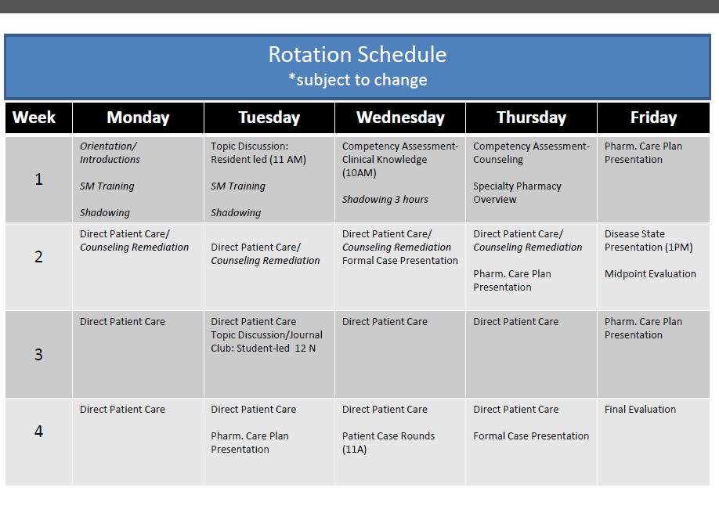

#2 Example of Rotation Schedule:

Week 1
Monday: Orientation/introductions
Tuesday: Community Pharmacy production/drop off review, pharmacist duties review
Wednesday: Direct Patient Care/ Counseling Remediation
Thursday: Drug Monograph Due
Friday: Direct Patient Care, immunizations review

Week 2
Monday: Direct Patient Care/Counseling Remediation
Tuesday: Direct Patient Care/Counseling Remediation
Wednesday: Legal review--control drug review
Thursday: Drug Monograph Due
Friday: MIDPOINT REVIEW

Week 3
Monday: OTC Drug review
Tuesday: Direct Patient Care
Wednesday: Inventory Management review
Thursday: Drug Monograph Due
Friday:

Week 4
Monday: Direct patient care
Tuesday: Direct patient care / *Formal Patient Case Due
Wednesday: Direct Patient Care
Thursday: Drug Monograph Due
Friday: FINAL EVALUATION

#3 Example of Rotation Schedule:

Sample Daily Rotation Schedule: 7AM-3:30PM*
*Student may need to arrive earlier or leave later depending on daily activities and amount of time needed to complete responsibilities and prepare for rounds. Updated rotation schedule to be obtained from assigned preceptor. A 30 minute lunch break may be taken.
Times | Monday | Tuesday | Wednesday | Thursday | Friday
Prior to Rounds (Rds) | Work-up new admissions, review patient labs, medication changes, develop problem lists, evaluate pain control and supportive care management, check MARs, etc. * Attend P &T, Critical Care meetings etc.
0800 –1100 | Rounds# | Rounds# | Rounds# | Rounds# |  | Rounds#
1100-1200 | ICW* | ICW* | ICW* | ICW* |  | ICW*
1200-1300 | ICW* | ICW* | ICW* | ICW* |  | ICW*
1300-1400 | ICW* or attend MUE, Formulary Sub-Committee Mtgs, Preceptor Journal Club, Student/Resident Interactive Teaching Experience (SPRITE), etc.
1400 - 1600 | Meet with preceptor and/or residents(s) for topic discussions, review new admissions, changes, evaluate therapeutic regimen, discuss presentations etc. (Please note, discussions may go past 1600 depending on availability of the preceptor)
PM | ICW*
* ICW = Individual Clinical Work: activities outlined below
#- Rounds times and days vary by unit and attendance will be determined by preceptor
*see sample calendar in appendix A.

